WEEK 02-01

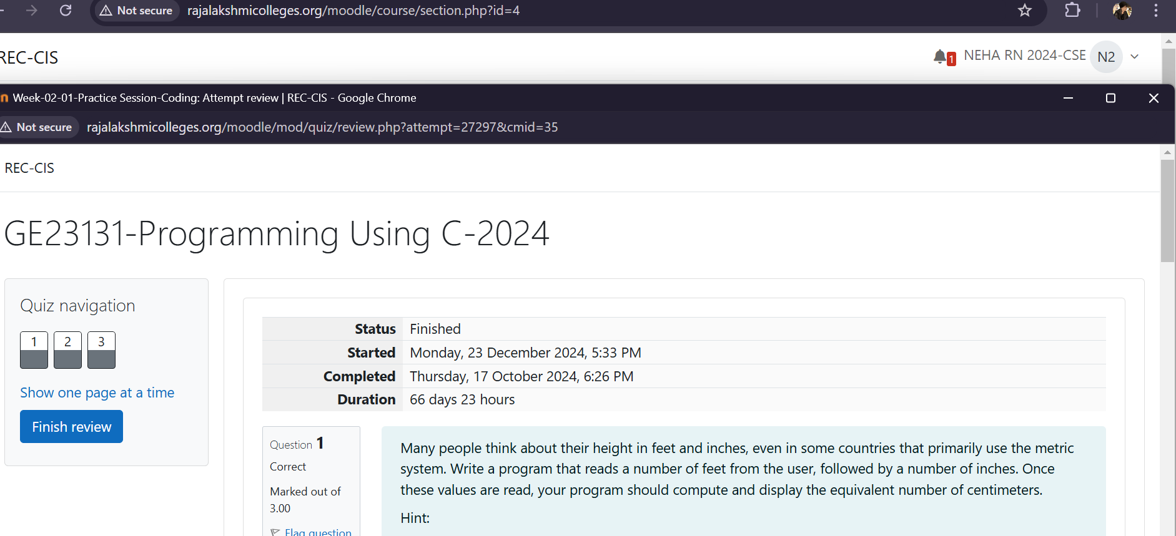

Experiment 1

Problem Statement: Many people think about their height in feet and inches, even in some countries that primarily use the metric system. Write a program that reads a number of feet from the user, followed by a number of inches. Once these values are read, your program should compute and display the equivalent number of centimeters

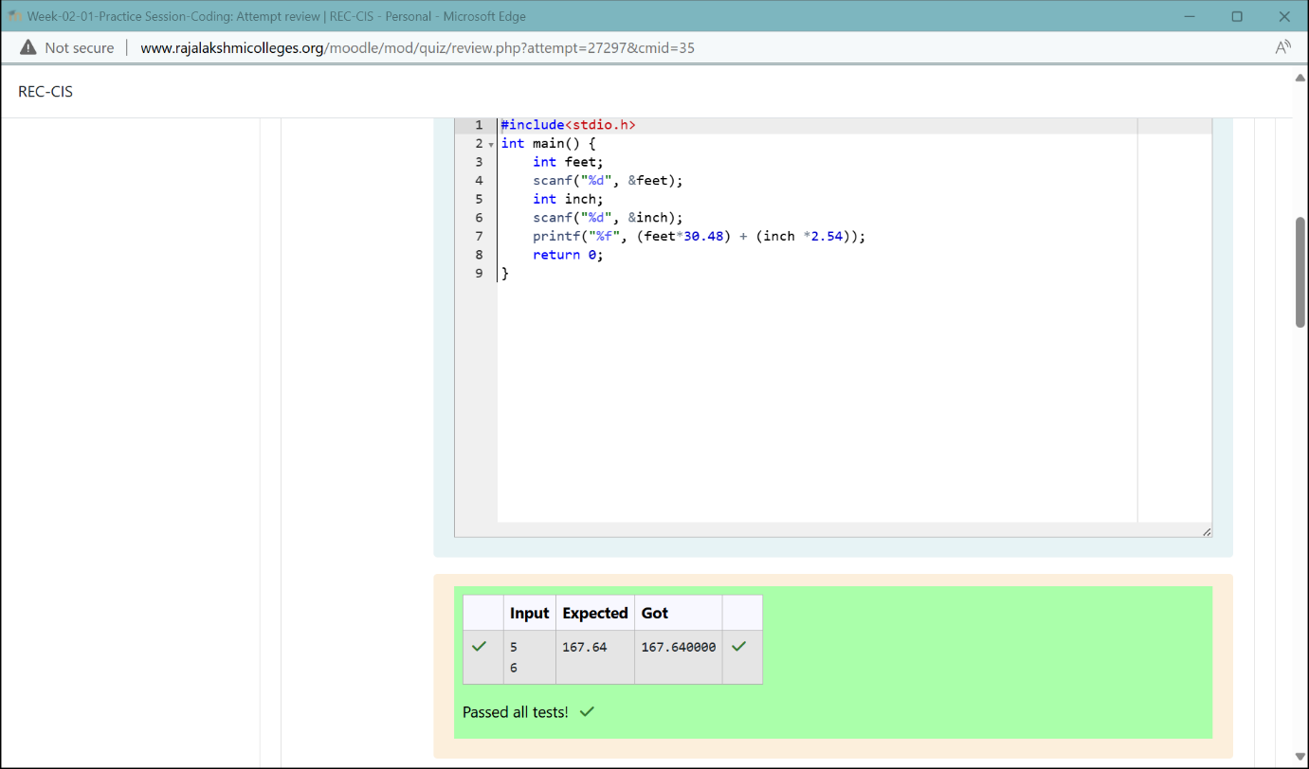

Experiment 2

Problem Statement: Create a program that reads two integers, a and b, from the user. Your program should compute and display: • The sum of a and b • The difference when b is subtracted from a • The product of a and b • The quotient when a is divided by b • The remainder when a is divided by b

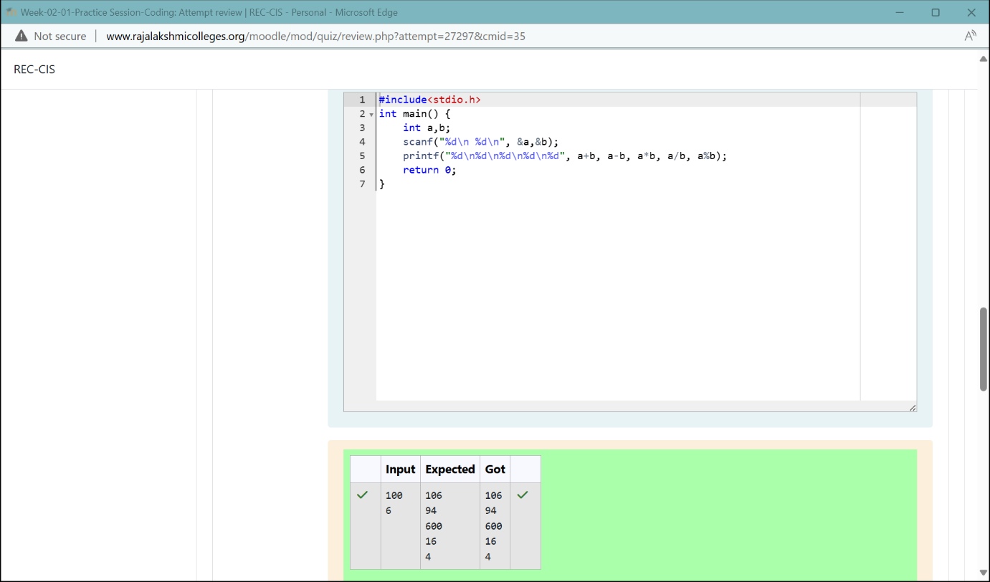

Experiment 3

Problem Statement: A bakery sells loaves of bread for $3.49 each. Day old bread is discounted by 60 percent. Write a program that begins by reading the number of loaves of day-old bread being purchased from the user. Then your program should display the regular price for the bread, the discount because it is a day old, and the total price. Each of these amounts should be displayed on its own line with an appropriate label. All of the values should be displayed using two decimal places.

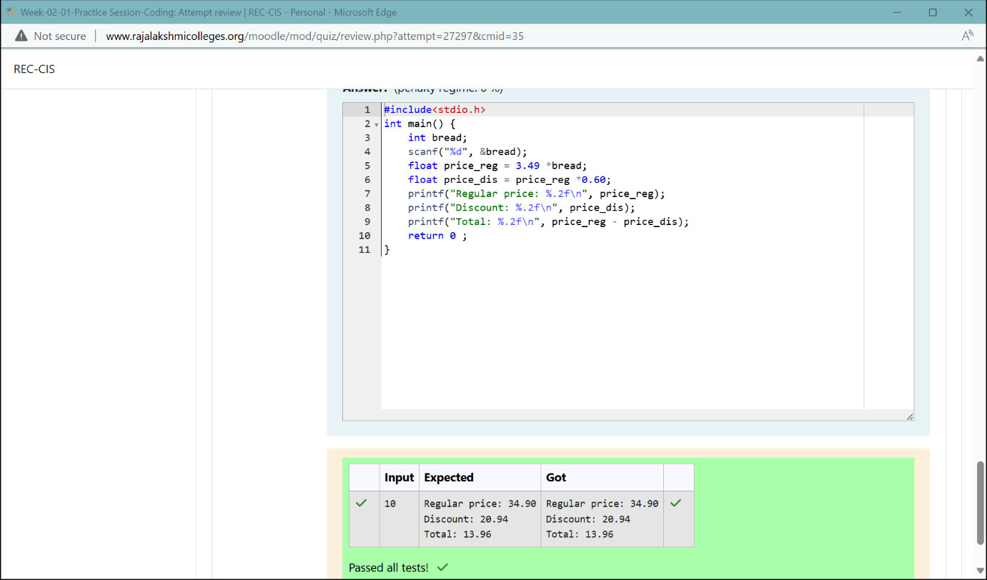

WEEK -02-02

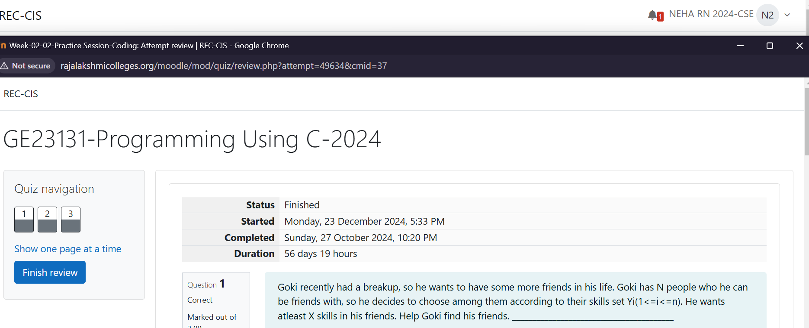

Experiment 4

Problem Statement: Goki recently had a breakup, so he wants to have some more friends in his life. Goki has N people who he can be friends with, so he decides to choose among them according to their skills set Yi(1<=i<=n). He wants atleast X skills in his friends. Help Goki find his friends.

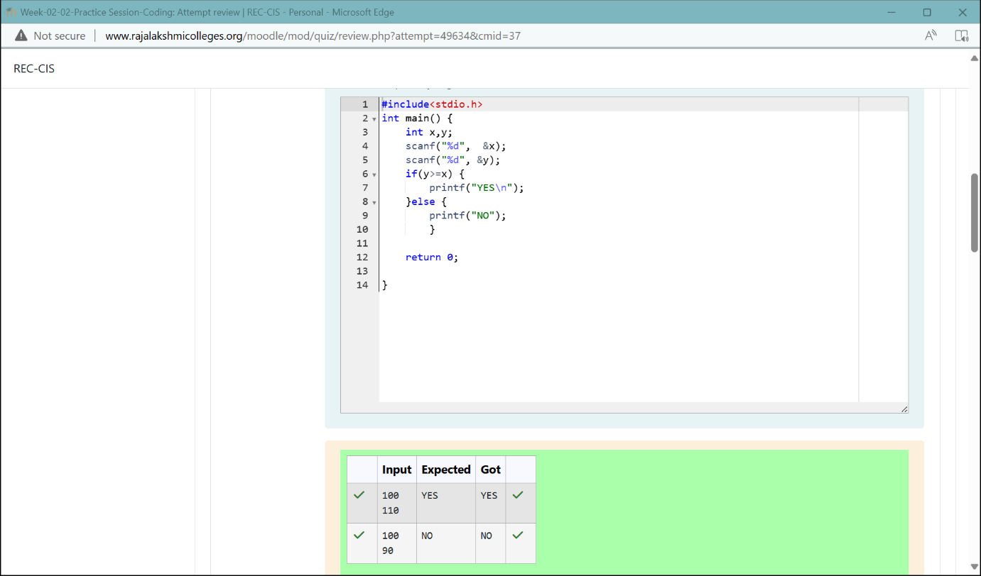

Experiment 5

Problem Statement: Before the outbreak of corona virus to the world, a meeting happened in a room in Wuhan. A person who attended that meeting had COVID-19 and no one in the room knew about it! So, everyone started shaking hands with everyone else in the room as a gesture of respect and after meeting unfortunately everyone got infected! Given the fact that any two persons shake hand exactly once, can you tell the total count of handshakes happened in that meeting?

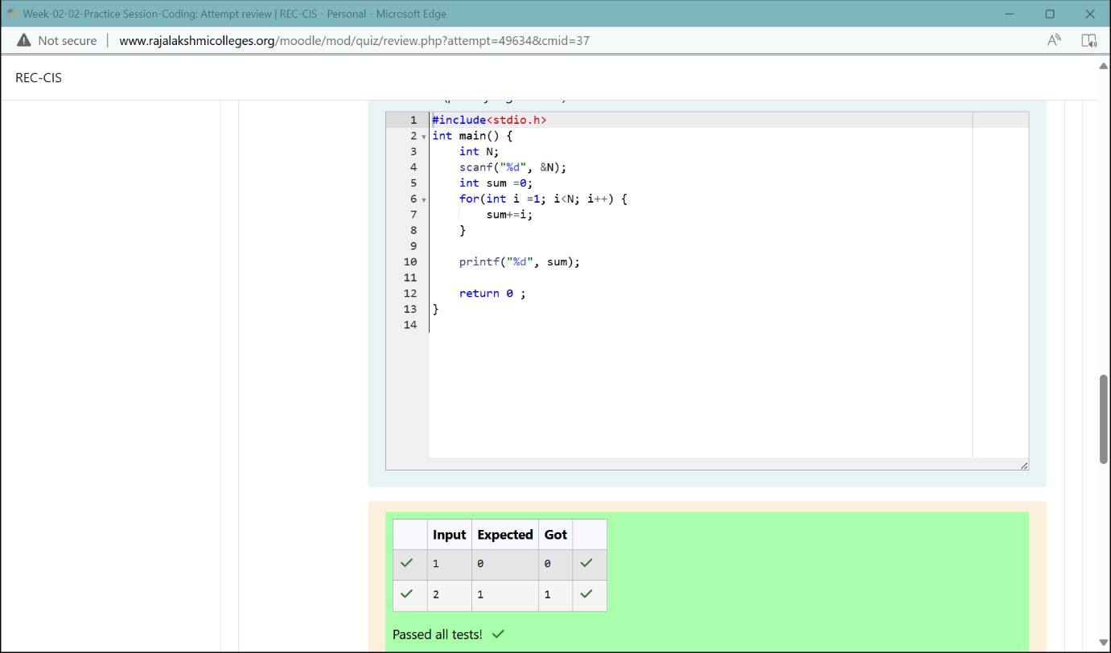

Experiment 6

Problem Statement: In our school days, all of us have enjoyed the Games period. Raghav loves to play cricket and is Captain of his team. He always wanted to win all cricket matches. But only one last Games period is left in school now. After that he will pass out from school. So, this match is very important to him. He does not want to lose it. So he has done a lot of planning to make sure his teams wins. He is worried about only one opponent - Jatin, who is very good batsman. Raghav has figured out 3 types of bowling techniques, that could be most beneficial for dismissing Jatin. He has given points to each of the 3 techniques. You need to tell him which is the maximum point value, so that Raghav can select best technique. 3 numbers are given in input. Output the maximum of these numbers.

